SQL Aggregate Functions

🌟 Definition
# Source: AI Source: Provided by: [Data Path: Persons Table -> ID Column: 1, Name_En Column: Motasem Essam] -> From: [ChatGPT] on [6/11/2026]
SQL Aggregate Functions are built-in functions that perform calculations on multiple rows and return a single result.
They are commonly used to calculate totals, averages, minimums, maximums, and counts.
Aggregate functions are often used with:
- SELECT
- GROUP BY
- HAVING

🎯 Purpose
# Source: AI Source: Provided by: [Data Path: Persons Table -> ID Column: 1, Name_En Column: Motasem Essam] -> From: [ChatGPT] on [6/11/2026]
Aggregate functions are used to:
- Count records
- Calculate totals
- Find averages
- Find the highest value
- Find the lowest value
- Summarize large amounts of data

🧠 Simple Example
# Source: AI Source: Provided by: [Data Path: Persons Table -> ID Column: 1, Name_En Column: Motasem Essam] -> From: [ChatGPT] on [6/11/2026]
Employees Table
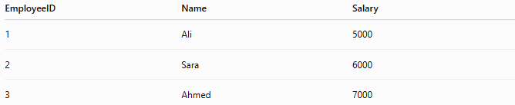
EmployeeID | Name | Salary
1 | Ali | 5000
2 | Sara | 6000
3 | Ahmed | 7000

SQL Statement
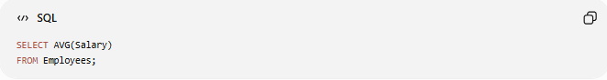
SELECT AVG(Salary)
FROM Employees;

Result
AVG(Salary)
6000
The average salary of all employees is 6000.

📝 Syntax
# Source: AI Source: Provided by: [Data Path: Persons Table -> ID Column: 1, Name_En Column: Motasem Essam] -> From: [ChatGPT] on [6/11/2026]
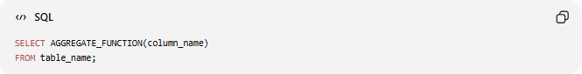
SELECT AGGREGATE_FUNCTION(column_name)
FROM table_name;

🔢 Types of SQL Aggregate Functions
# Source: AI Source: Provided by: [Data Path: Persons Table -> ID Column: 1, Name_En Column: Motasem Essam] -> From: [ChatGPT] on [6/11/2026]
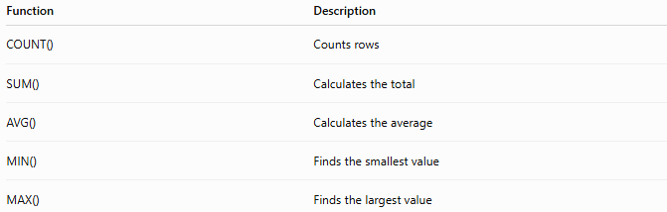
Function | Description
COUNT() | Counts rows
SUM() | Calculates the total
AVG() | Calculates the average
MIN() | Finds the smallest value
MAX() | Finds the largest value

1️⃣ COUNT()
# Source: AI Source: Provided by: [Data Path: Persons Table -> ID Column: 1, Name_En Column: Motasem Essam] -> From: [ChatGPT] on [6/11/2026]
Counts the number of rows.
Example

SELECT COUNT(*)
FROM Employees;
Result
COUNT(*)
3

Count Non-NULL Values

SELECT COUNT(Department)
FROM Employees;
Counts only rows where Department is not NULL.

2️⃣ SUM()
# Source: AI Source: Provided by: [Data Path: Persons Table -> ID Column: 1, Name_En Column: Motasem Essam] -> From: [ChatGPT] on [6/11/2026]
Calculates the total of a numeric column.
Example

SELECT SUM(Salary)
FROM Employees;
Result
SUM(Salary)
18000

3️⃣ AVG()
# Source: AI Source: Provided by: [Data Path: Persons Table -> ID Column: 1, Name_En Column: Motasem Essam] -> From: [ChatGPT] on [6/11/2026]
Calculates the average value.
Example
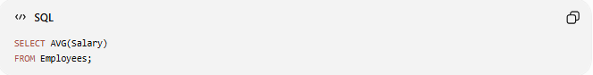
SELECT AVG(Salary)
FROM Employees;
Result
AVG(Salary)
6000

4️⃣ MIN()
# Source: AI Source: Provided by: [Data Path: Persons Table -> ID Column: 1, Name_En Column: Motasem Essam] -> From: [ChatGPT] on [6/11/2026]
Returns the smallest value.
Example

SELECT MIN(Salary)
FROM Employees;
Result
MIN(Salary)
5000

5️⃣ MAX()
# Source: AI Source: Provided by: [Data Path: Persons Table -> ID Column: 1, Name_En Column: Motasem Essam] -> From: [ChatGPT] on [6/11/2026]
Returns the largest value.
Example

SELECT MAX(Salary)
FROM Employees;
Result
MAX(Salary)
7000

📚 Aggregate Functions with WHERE
# Source: AI Source: Provided by: [Data Path: Persons Table -> ID Column: 1, Name_En Column: Motasem Essam] -> From: [ChatGPT] on [6/11/2026]
Find the average salary of IT employees.
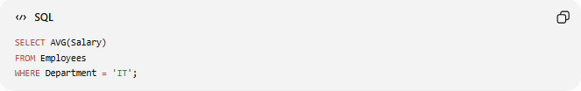
SELECT AVG(Salary)
FROM Employees
WHERE Department = 'IT';

📚 Aggregate Functions with GROUP BY
# Source: AI Source: Provided by: [Data Path: Persons Table -> ID Column: 1, Name_En Column: Motasem Essam] -> From: [ChatGPT] on [6/11/2026]
Calculate the total salary for each department.
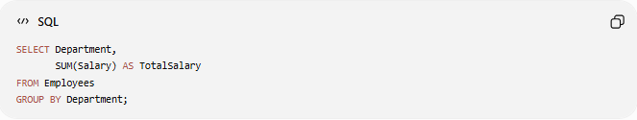
SELECT Department,
SUM(Salary) AS TotalSalary
FROM Employees
GROUP BY Department;

Result
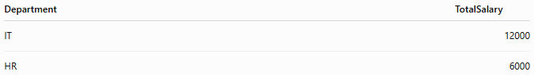
Department | TotalSalary
IT | 12000
HR | 6000

📚 Aggregate Functions with HAVING
# Source: AI Source: Provided by: [Data Path: Persons Table -> ID Column: 1, Name_En Column: Motasem Essam] -> From: [ChatGPT] on [6/11/2026]
Show departments whose total salary exceeds 10000.
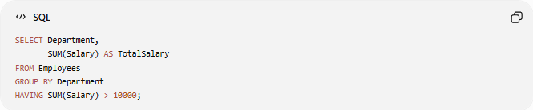
SELECT Department,
SUM(Salary) AS TotalSalary
FROM Employees
GROUP BY Department
HAVING SUM(Salary) > 10000;

Result
Department | TotalSalary
IT | 12000

📊 Summary of Aggregate Functions
# Source: AI Source: Provided by: [Data Path: Persons Table -> ID Column: 1, Name_En Column: Motasem Essam] -> From: [ChatGPT] on [6/11/2026]
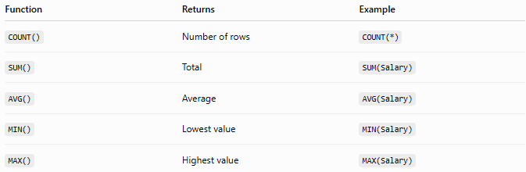
Function | Returns | Example
COUNT() | Number of rows | COUNT(*)
SUM() | Total | SUM(Salary)
AVG() | Average | AVG(Salary)
MIN() | Lowest value | MIN(Salary)
MAX() | Highest value | MAX(Salary)

🛠️ Complete Test Example

1️⃣ Create Table
# Source: AI Source: Provided by: [Data Path: Persons Table -> ID Column: 1, Name_En Column: Motasem Essam] -> From: [ChatGPT] on [6/11/2026]
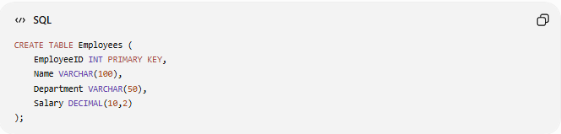
CREATE TABLE Employees (
EmployeeID INT PRIMARY KEY,
Name VARCHAR(100),
Department VARCHAR(50),
Salary DECIMAL(10,2)
);

2️⃣ Insert Sample Data
# Source: AI Source: Provided by: [Data Path: Persons Table -> ID Column: 1, Name_En Column: Motasem Essam] -> From: [ChatGPT] on [6/11/2026]
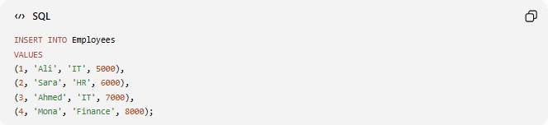
INSERT INTO Employees
VALUES
(1, 'Ali', 'IT', 5000),
(2, 'Sara', 'HR', 6000),
(3, 'Ahmed', 'IT', 7000),
(4, 'Mona', 'Finance', 8000);

3️⃣ Count Employees
# Source: AI Source: Provided by: [Data Path: Persons Table -> ID Column: 1, Name_En Column: Motasem Essam] -> From: [ChatGPT] on [6/11/2026]

SELECT COUNT(*)
FROM Employees;

4️⃣ Total Salary
# Source: AI Source: Provided by: [Data Path: Persons Table -> ID Column: 1, Name_En Column: Motasem Essam] -> From: [ChatGPT] on [6/11/2026]

SELECT SUM(Salary)
FROM Employees;

5️⃣ Average Salary
# Source: AI Source: Provided by: [Data Path: Persons Table -> ID Column: 1, Name_En Column: Motasem Essam] -> From: [ChatGPT] on [6/11/2026]
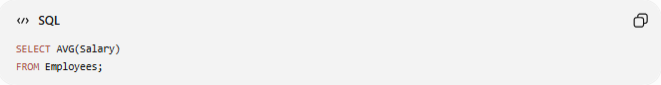
SELECT AVG(Salary)
FROM Employees;

6️⃣ Lowest Salary
# Source: AI Source: Provided by: [Data Path: Persons Table -> ID Column: 1, Name_En Column: Motasem Essam] -> From: [ChatGPT] on [6/11/2026]

SELECT MIN(Salary)
FROM Employees;

7️⃣ Highest Salary
# Source: AI Source: Provided by: [Data Path: Persons Table -> ID Column: 1, Name_En Column: Motasem Essam] -> From: [ChatGPT] on [6/11/2026]

SELECT MAX(Salary)
FROM Employees;

8️⃣ Total Salary by Department
# Source: AI Source: Provided by: [Data Path: Persons Table -> ID Column: 1, Name_En Column: Motasem Essam] -> From: [ChatGPT] on [6/11/2026]
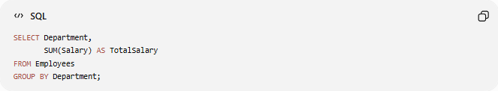
SELECT Department,
SUM(Salary) AS TotalSalary
FROM Employees
GROUP BY Department;

Real Example

prepared commands

1️⃣ Create Table
# Source: ScreenShot Source: Provided by: [Persons Table -> ID Column: 1, Name_En Column: Motasem Essam] -> Tool: [Automation Table -> ID Column: 16, Name_En Column: Screen Capture] -> From [Operating System: Wampserver64 -> phpmyadmin] on [6/11/2026]
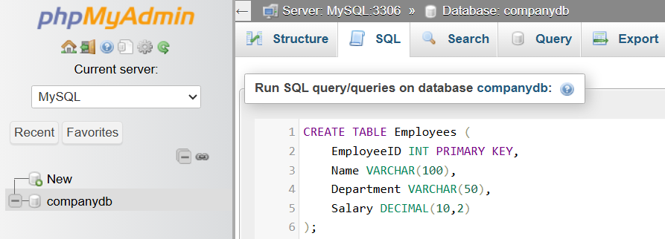
CREATE TABLE Employees (
EmployeeID INT PRIMARY KEY,
Name VARCHAR(100),
Department VARCHAR(50),
Salary DECIMAL(10,2)
);
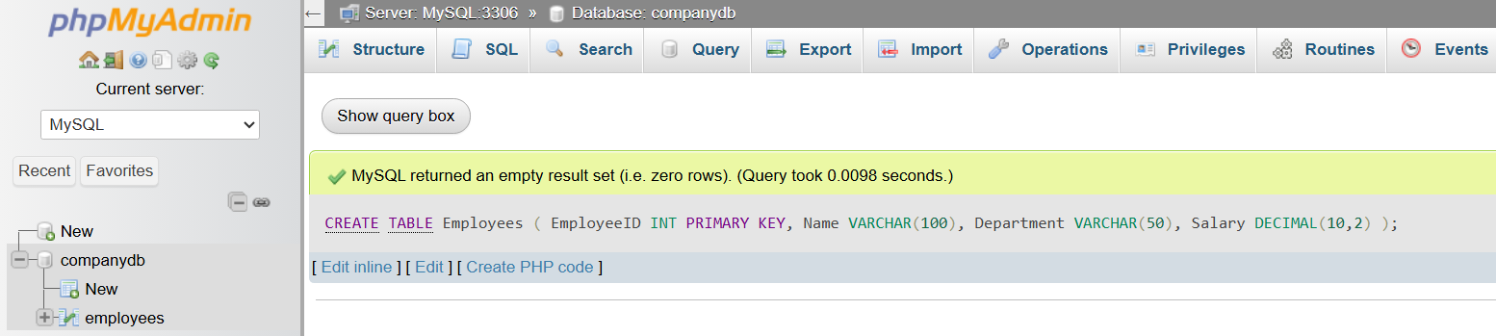

2️⃣ Insert Sample Data
# Source: ScreenShot Source: Provided by: [Persons Table -> ID Column: 1, Name_En Column: Motasem Essam] -> Tool: [Automation Table -> ID Column: 16, Name_En Column: Screen Capture] -> From [Operating System: Wampserver64 -> phpmyadmin] on [6/11/2026]
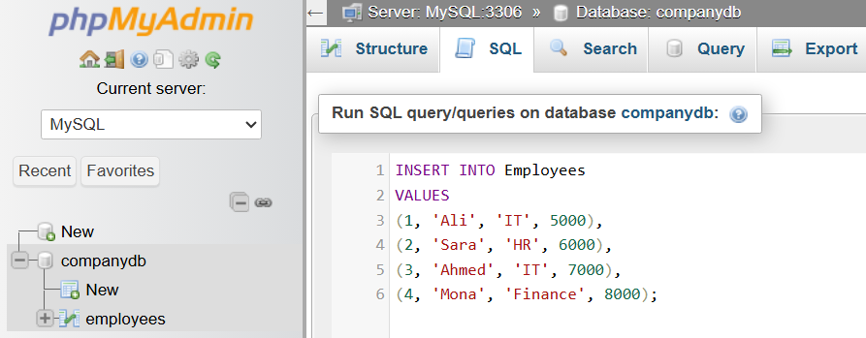
INSERT INTO Employees
VALUES
(1, 'Ali', 'IT', 5000),
(2, 'Sara', 'HR', 6000),
(3, 'Ahmed', 'IT', 7000),
(4, 'Mona', 'Finance', 8000);
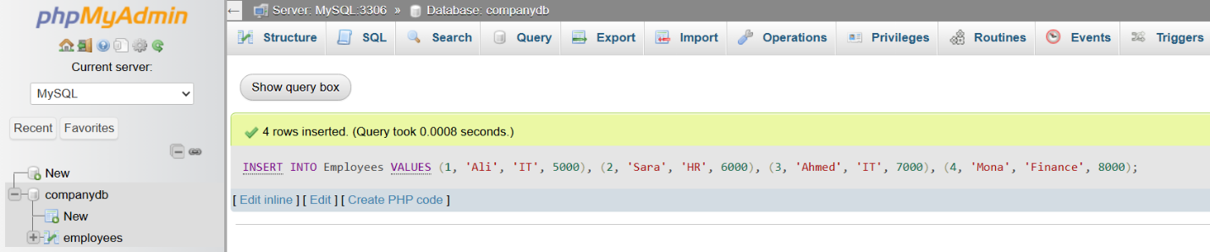

basic command

3️⃣ Count Employees
# Source: ScreenShot Source: Provided by: [Persons Table -> ID Column: 1, Name_En Column: Motasem Essam] -> Tool: [Automation Table -> ID Column: 16, Name_En Column: Screen Capture] -> From [Operating System: Wampserver64 -> phpmyadmin] on [6/11/2026]
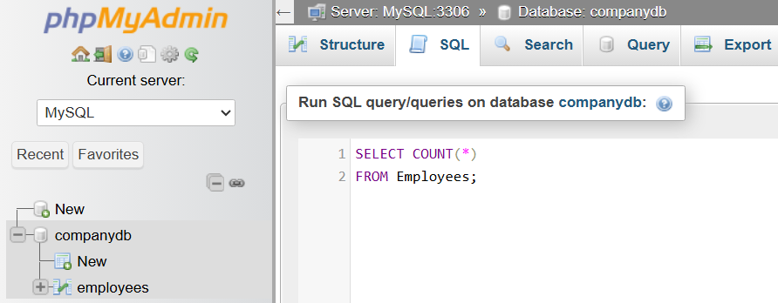
SELECT COUNT(*)
FROM Employees;
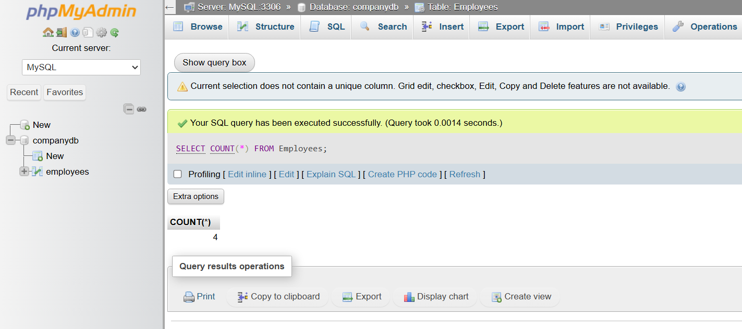

4️⃣ Total Salary
# Source: ScreenShot Source: Provided by: [Persons Table -> ID Column: 1, Name_En Column: Motasem Essam] -> Tool: [Automation Table -> ID Column: 16, Name_En Column: Screen Capture] -> From [Operating System: Wampserver64 -> phpmyadmin] on [6/11/2026]
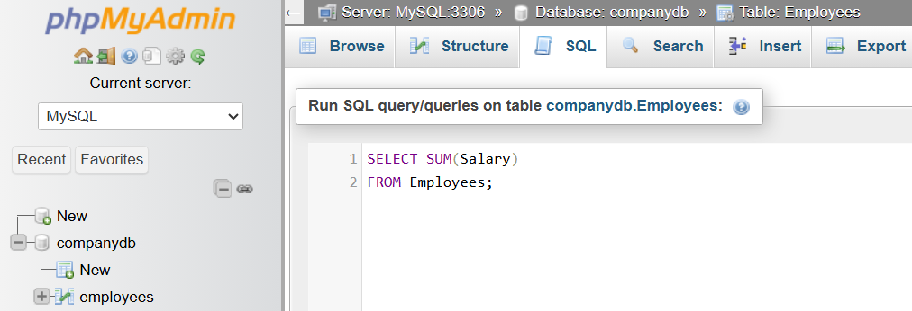
SELECT SUM(Salary)
FROM Employees;
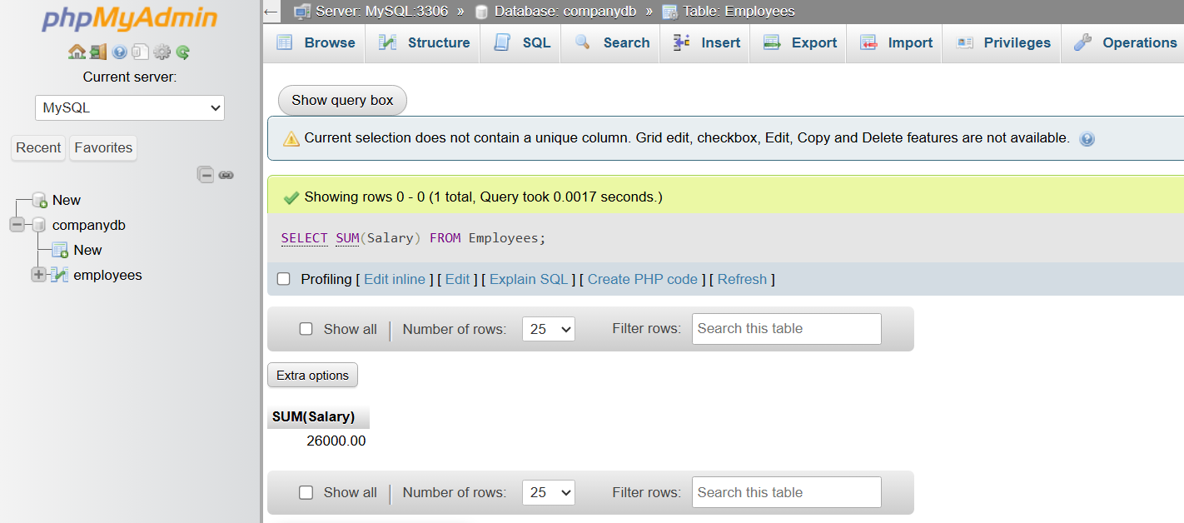

5️⃣ Average Salary
# Source: ScreenShot Source: Provided by: [Persons Table -> ID Column: 1, Name_En Column: Motasem Essam] -> Tool: [Automation Table -> ID Column: 16, Name_En Column: Screen Capture] -> From [Operating System: Wampserver64 -> phpmyadmin] on [6/11/2026]
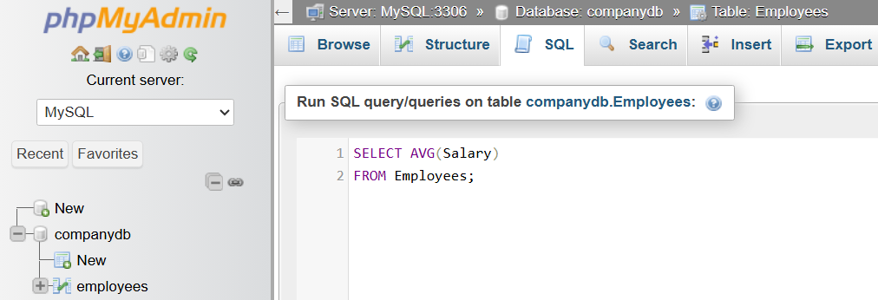
SELECT AVG(Salary)
FROM Employees;
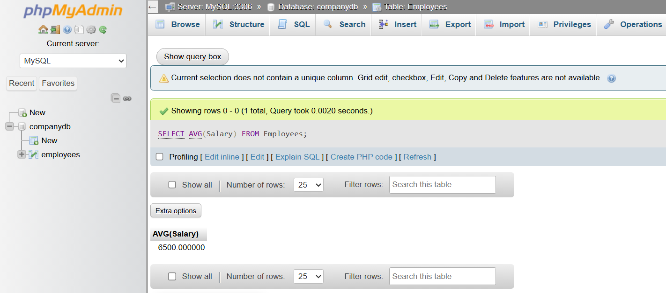

6️⃣ Lowest Salary
# Source: ScreenShot Source: Provided by: [Persons Table -> ID Column: 1, Name_En Column: Motasem Essam] -> Tool: [Automation Table -> ID Column: 16, Name_En Column: Screen Capture] -> From [Operating System: Wampserver64 -> phpmyadmin] on [6/11/2026]
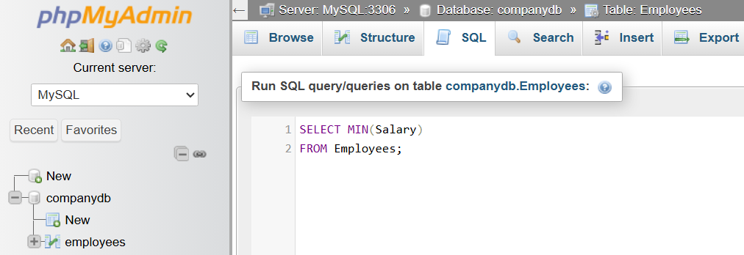
SELECT MIN(Salary)
FROM Employees;
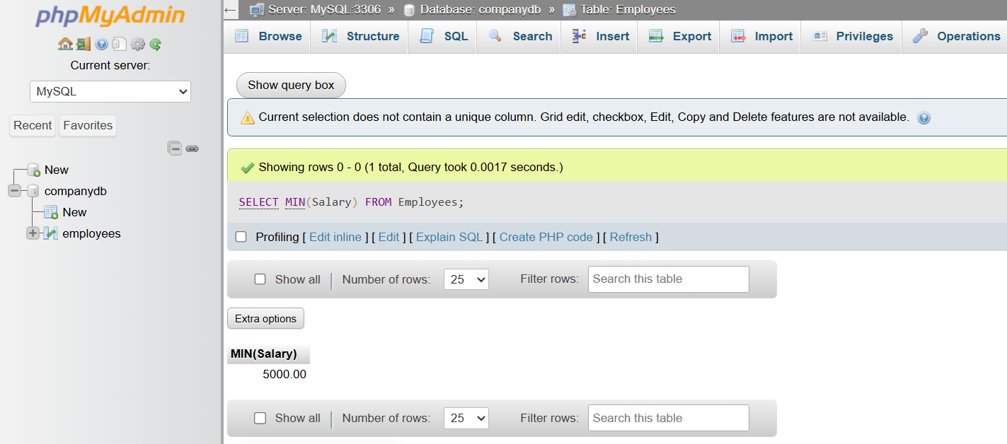

7️⃣ Highest Salary
# Source: ScreenShot Source: Provided by: [Persons Table -> ID Column: 1, Name_En Column: Motasem Essam] -> Tool: [Automation Table -> ID Column: 16, Name_En Column: Screen Capture] -> From [Operating System: Wampserver64 -> phpmyadmin] on [6/11/2026]
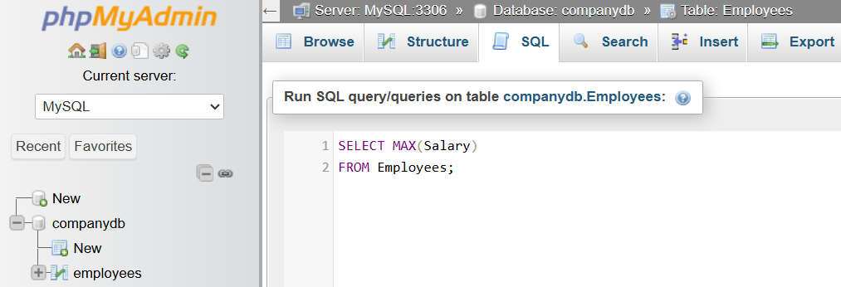
SELECT MAX(Salary)
FROM Employees;
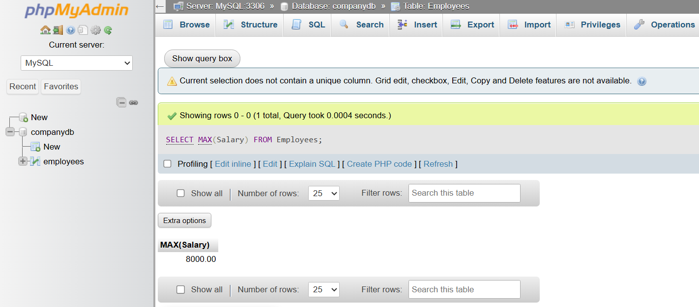

8️⃣ Total Salary by Department
# Source: ScreenShot Source: Provided by: [Persons Table -> ID Column: 1, Name_En Column: Motasem Essam] -> Tool: [Automation Table -> ID Column: 16, Name_En Column: Screen Capture] -> From [Operating System: Wampserver64 -> phpmyadmin] on [6/11/2026]
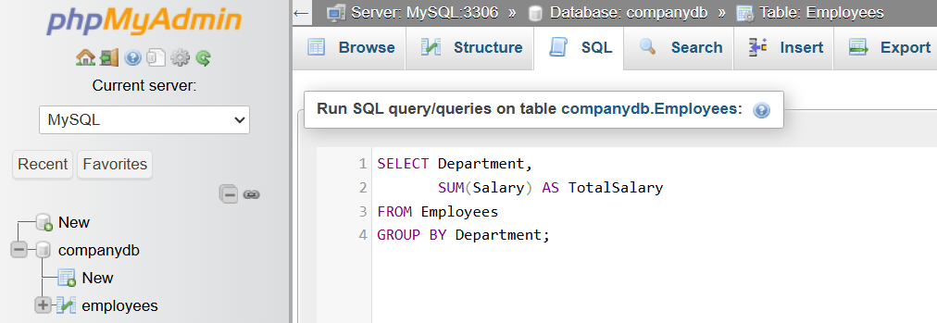
SELECT Department,
SUM(Salary) AS TotalSalary
FROM Employees
GROUP BY Department;
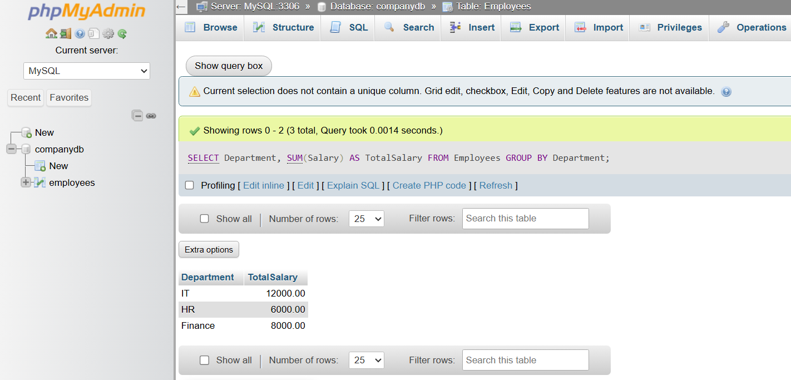

📊 Sample Results
# Source: AI Source: Provided by: [Data Path: Persons Table -> ID Column: 1, Name_En Column: Motasem Essam] -> From: [ChatGPT] on [6/11/2026]
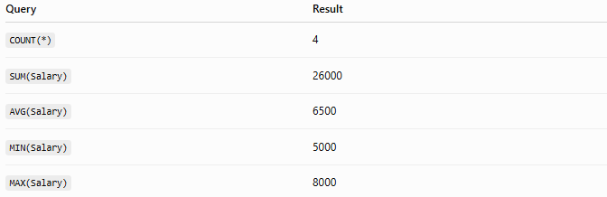
Query | Result
COUNT(*) | 4
SUM(Salary) | 26000
AVG(Salary) | 6500
MIN(Salary) | 5000
MAX(Salary) | 8000

⚠️ Important Notes
# Source: AI Source: Provided by: [Data Path: Persons Table -> ID Column: 1, Name_En Column: Motasem Essam] -> From: [ChatGPT] on [6/11/2026]
- Aggregate functions ignore NULL values (except COUNT(*), which counts all rows).
- SUM() and AVG() work only with numeric columns.
- GROUP BY is used to calculate aggregates for each group.
- HAVING filters groups after aggregation.

⚖️ Aggregate Functions vs Scalar Functions
# Source: AI Source: Provided by: [Data Path: Persons Table -> ID Column: 1, Name_En Column: Motasem Essam] -> From: [ChatGPT] on [6/11/2026]
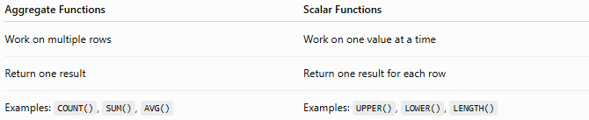
Aggregate Functions | Scalar Functions
Work on multiple rows | Work on one value at a time
Return one result | Return one result for each row
Examples: COUNT(), SUM(), AVG() | Examples: UPPER(), LOWER(), LENGTH()

🔢 Aggregate Function Workflow
# Source: AI Source: Provided by: [Data Path: Persons Table -> ID Column: 1, Name_En Column: Motasem Essam] -> From: [ChatGPT] on [6/11/2026]
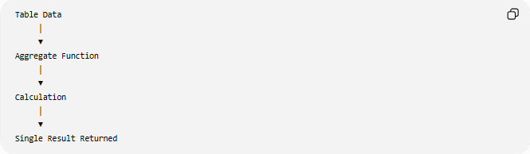
Table Data
│
▼
Aggregate Function
│
▼
Calculation
│
▼
Single Result Returned

🧠 Simple Analogy
# Source: AI Source: Provided by: [Data Path: Persons Table -> ID Column: 1, Name_En Column: Motasem Essam] -> From: [ChatGPT] on [6/11/2026]
Imagine a class of students with exam scores.
- COUNT() → How many students are in the class?
- SUM() → What is the total of all scores?
- AVG() → What is the average score?
- MIN() → What is the lowest score?
- MAX() → What is the highest score?
Instead of looking at each student individually, aggregate functions summarize the entire class into meaningful statistics.

🧭 Summary
# Source: AI Source: Provided by: [Data Path: Persons Table -> ID Column: 1, Name_En Column: Motasem Essam] -> From: [ChatGPT] on [6/11/2026]
SQL Aggregate Functions perform calculations on a group of rows and return a single summarized value. The most common aggregate functions are COUNT(), SUM(), AVG(), MIN(), and MAX(). They are widely used with SELECT, GROUP BY, and HAVING to analyze, summarize, and report data stored in relational databases.

